1. ****Raspberry Pi platform ------- PS2_control****

****Part1--- Wiring of HardWare****

**1.1)You need to prepare the Yahboom PS2 handle kit,4WD car and the DuPont lines. As shown below.**

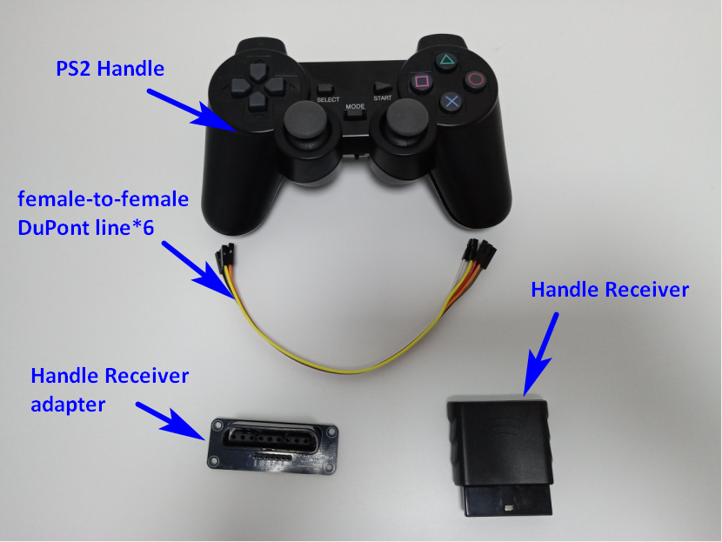

**1.2) We need to connect Handle Receiver to expansion board.**

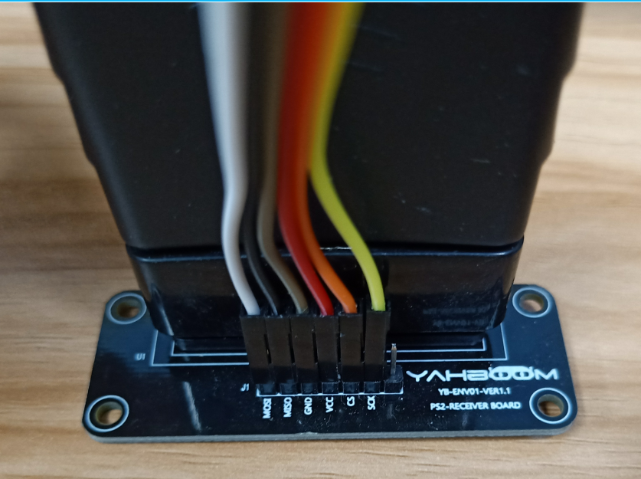

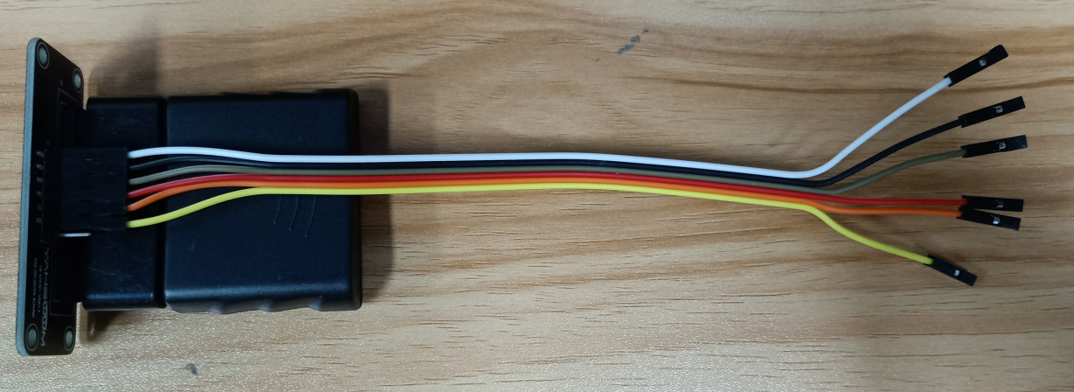

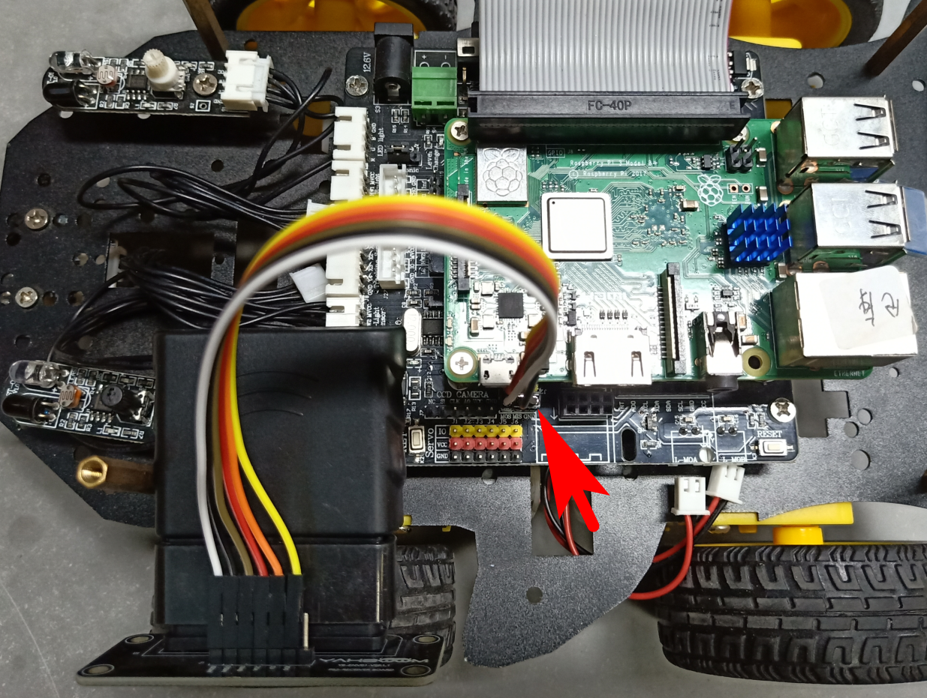

1.3) Open the power switch of PS handle, you will see green light on PS handle is flashing.

Open the power switch of robot car, you will see red light on Handle Receiver is keep on, green light on Handle Receiver is flashing.

****Wait patiently for a while, they** will automatically pair and connect.**

1.4)After successfully connected, you can see green light on Handle Receiver stop flashing and keep on. Green light on PS handle stop flashing and keep on.

As shown below.

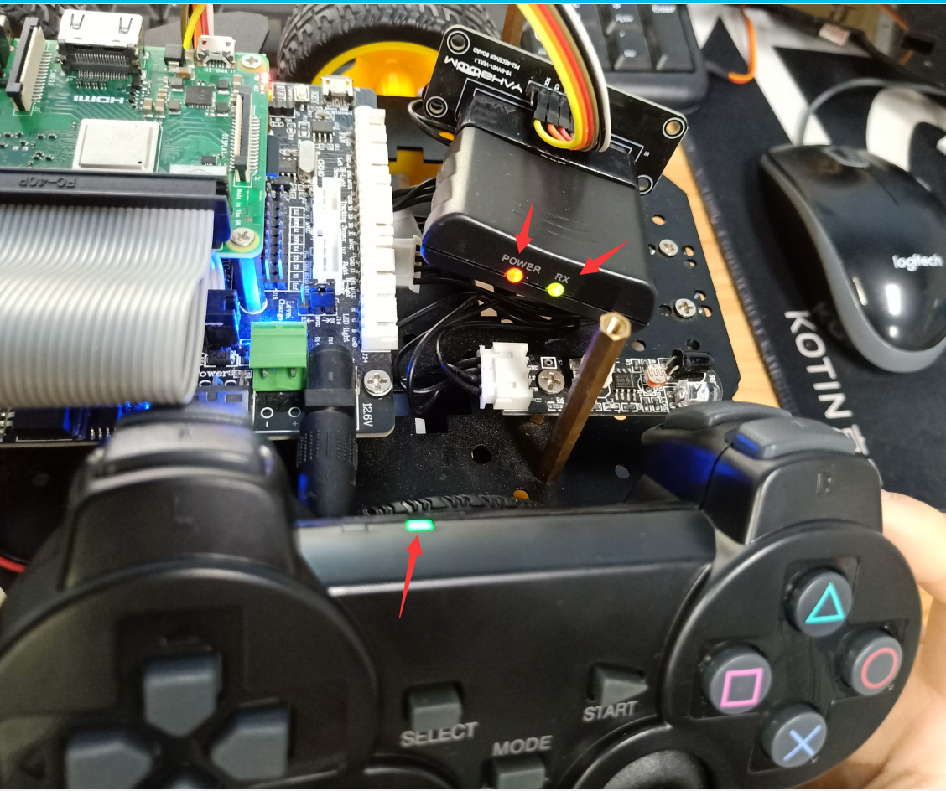

****Part 2---Open SPI** service**

2.1)We need to open SPI service of Raspberry Pi system.

Input command: sudo raspi-config



You will see interface as shown below:

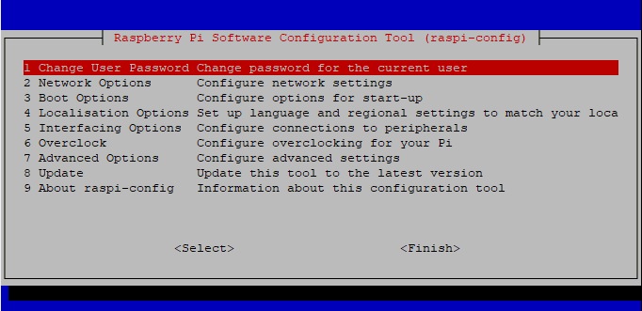

2.2) We need to choose 【Interfacing Options】.

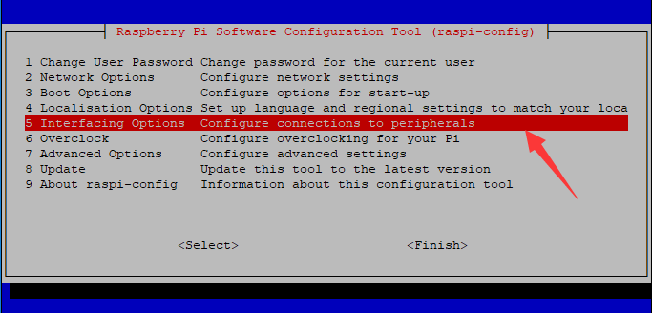

2.3) We need to choose 【SPI】.

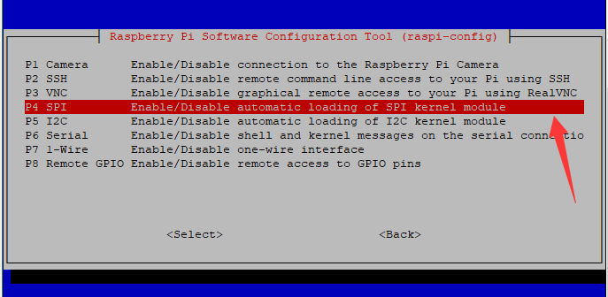

2.4) We need to enable 【SPI】.

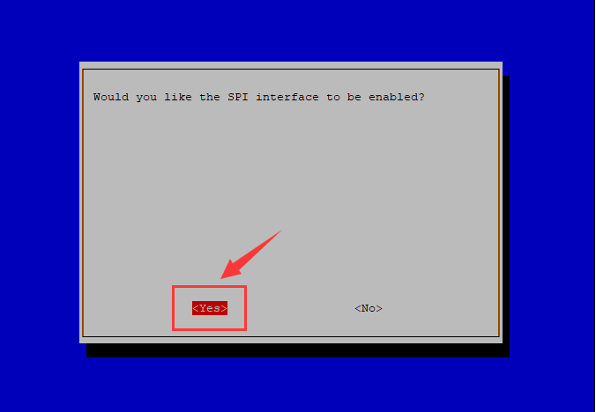

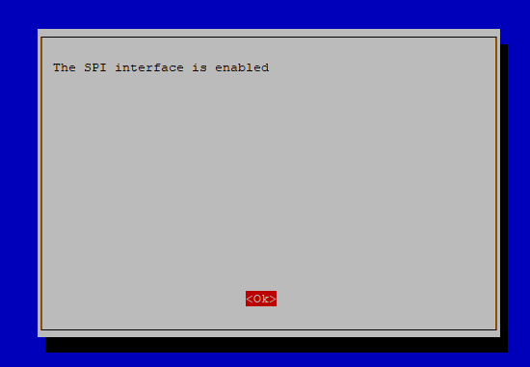

**2.5 Restart Raspberry Pi.**

****Part 3---T**ransfer Code**

You need to remotely transfer the PS2_Control.c or PS2_control.py we provide to the Raspberry Pi image system via SSH.

**!Note: After my test, I found that PS2_Control.c control is better. It is recommended to use PS2_Control.c instead of PS2_control.py.**

The transfer steps are as follows:

3.1)Get the WinSCP transfer tool and click on the location shown below to log in to the Raspberry Pi system.

(The IP address is 192.168.50.1 and the password is yahboom. Just for my image)

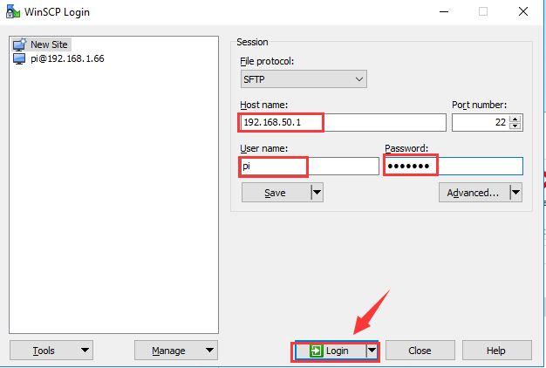

3.2)You can create a new folder to Storage PS2 control code. As shown below.

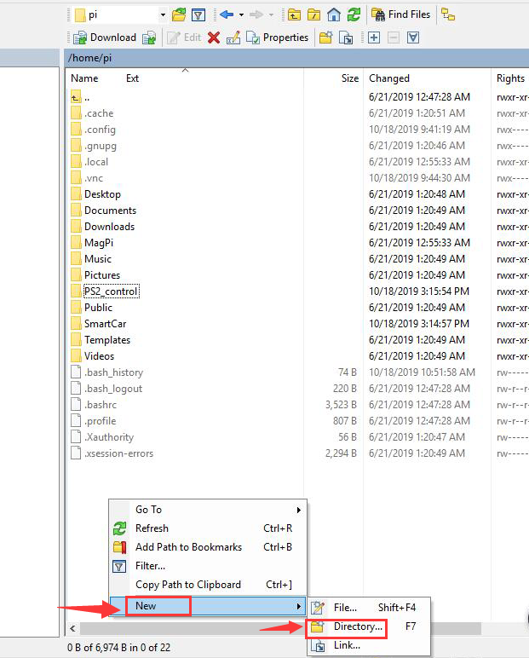

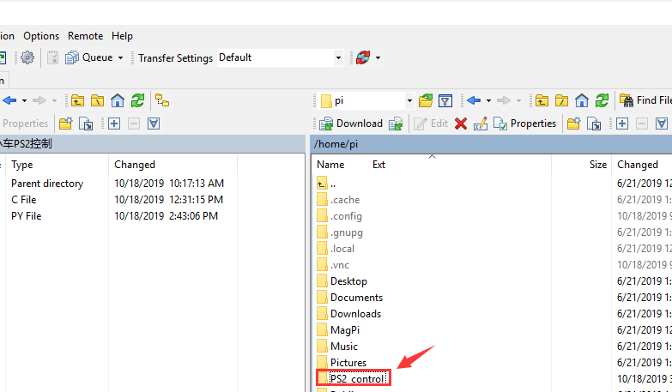

3.3)We need to drag the PS2_Control.c or PS2_control.py file to the right Raspberry Pi system.

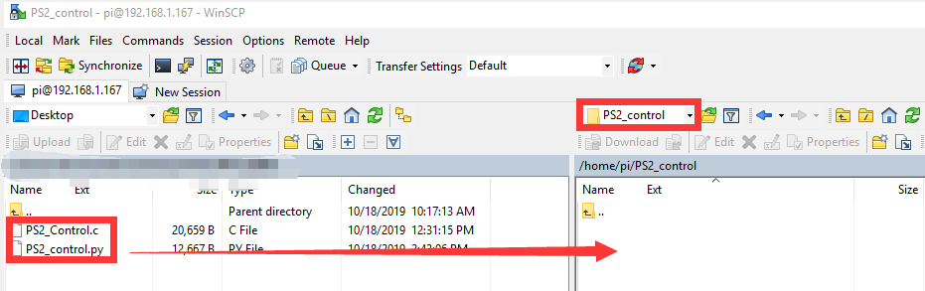

3.4) After the drag and drop is completed, as shown in the figure below, we can see PS2_Control.c or PS2_control.py in the Raspberry Pi system on the right.

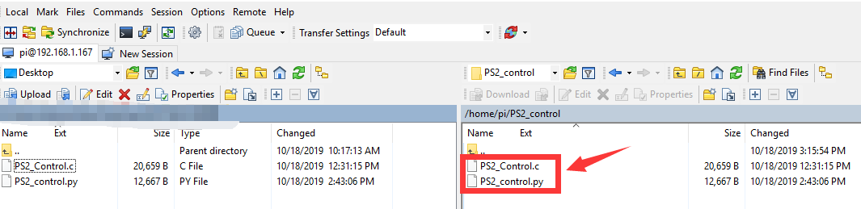

After the above steps, we have successfully transferred the PS2_Control.c or PS2_control.py file to the Raspberry Pi image.

****Part 4---Running Code****

4.1)You need to remotely log in to the Raspberry Pi system via putty, as shown below: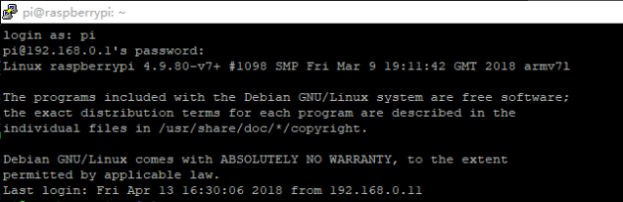

4.2) Switch the root user.

You need to enter the command: **su**

Then enter the password yahboom

(the password here is hidden and can't be seen, please be careful not to enter the error!)

At this point we successfully entered the root privileges, as shown below:

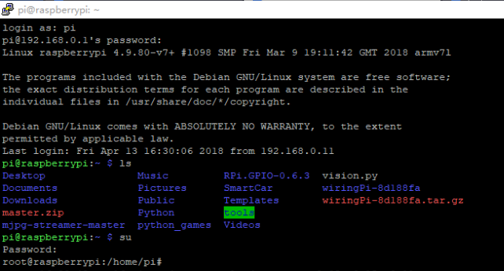

4.3)You need to enter the command: top

This command is to view the process ID of all processes in the Raspberry Pi system.

As shown in the figure below, we can see that the 519 process number is a Bluetooth remote process, you need to remember this number.

(Note! Different Raspberry Pi process numbers are different. Please refer to the process shown in your own system)

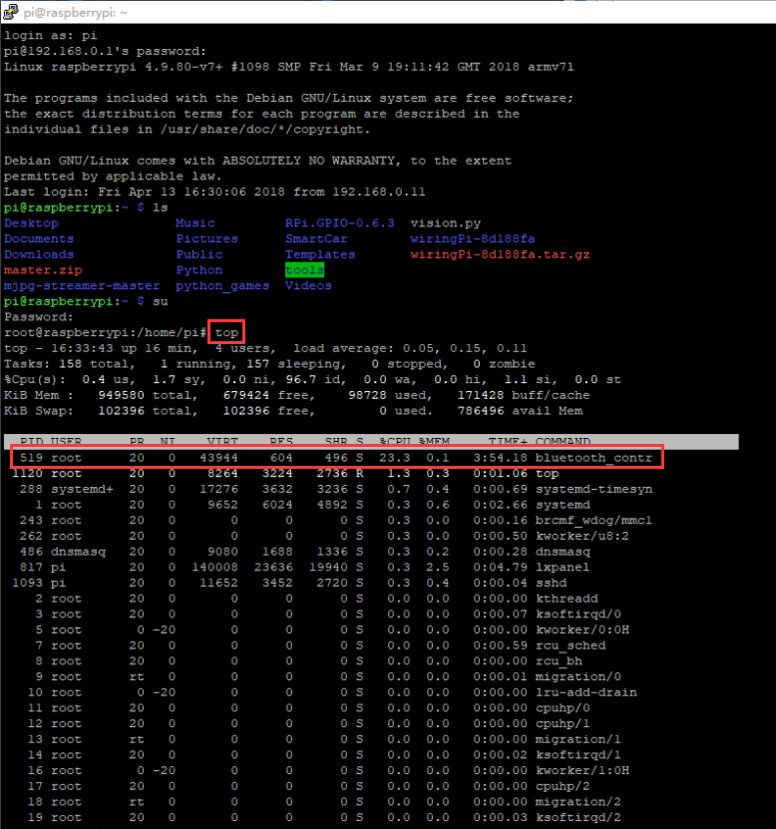

4.4) After obtaining the Bluetooth process number, press **ctrl+z** on the keyboard to exit this interface.

4.5) We must kill the Bluetooth process in order to avoid conflicts between the PS2_control process and the Bluetooth process.

Enter the command: kill -9 519

As shown below:

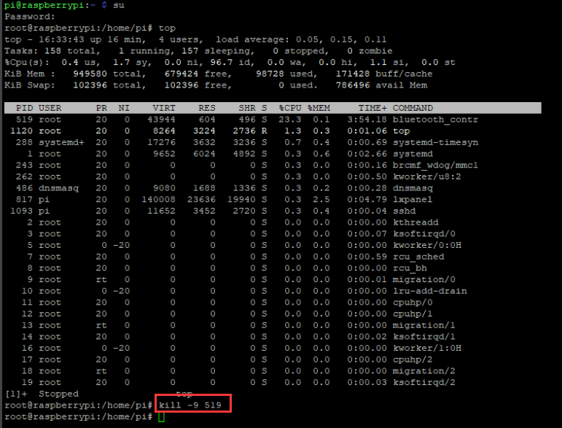

4.6) We need to go to the PS2_control directory:

Enter command: cd PS2_control

   ls

We can see the PS2_Control.c and PS2_control.py file inside.

As shown below:

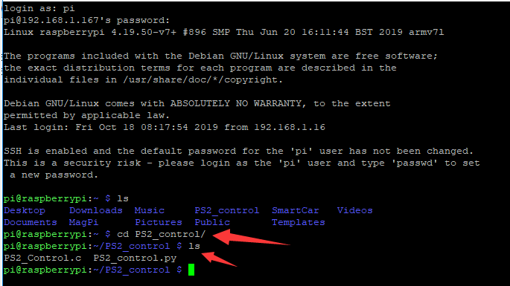

**For PS2_Control.c**

Enter the command:

sudo gcc PS2_Control.c -o PS2_Control -lwiringPi -lpthread

This command is to compile PS2_Control.c generates the executable file PS2_Control., which is correct as long as no error is reported during compilation, as shown in the following figure.



Enter the command:

./PS2_Control

This command is to run the executable.



Then, you can control the robot car by PS2 handle. At the same time, we can see that some data will be printed.

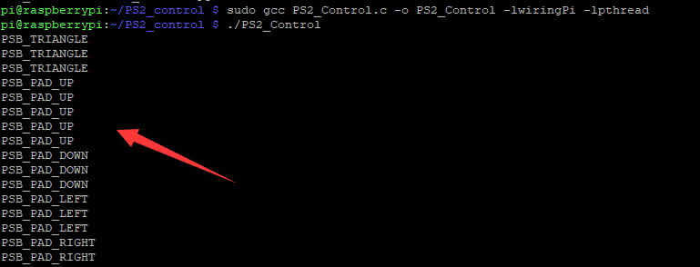

**For PS2_control.py**

Enter the command:

sudo python PS2_control.py

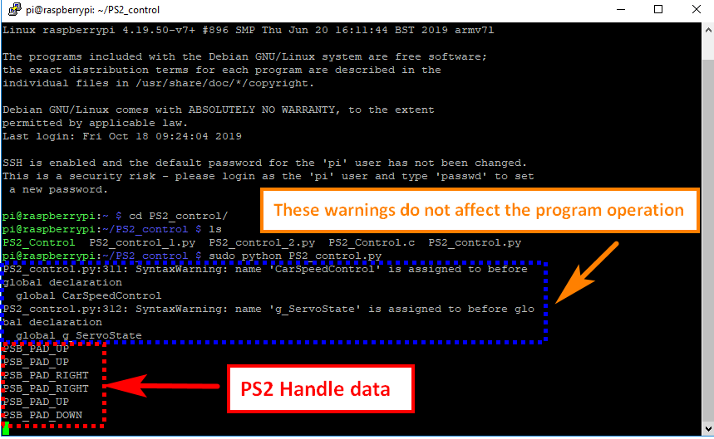

Then, you can control the robot car by PS2 handle. At the same time, we can see that some data will be printed.

****Part 5---Handle button function definition****

